**Module 9**

**Name: Upadhyay Sachin Naresh**

**Batch ID: AIWDEOB 300821**

**Topic name: CNN (Data augmentation)**

Apply data augmentation techniques(rotation, zoom, width shift , height shift and horizontal flip) for the following images

Importing Required libraries

import cv2

import os

from PIL import Image

from glob import glob

import numpy as np

import matplotlib.pyplot as plt

from skimage import io

Clone dataset into Google colab

!git clone https://github.com/nithindsouza/CNN_data_aug_dataset.git

Assigning data to a variable

img_data = '/content/CNN_data_aug_dataset/images/'

aug_dir = '/content/CNN_data_aug_dataset/augmented/'

Counting total number of images present

print('total images:', len(os.listdir(img_data)))

Viewing file names

os.listdir(img_data)

Displaying all the images in a subplot

Put all images in the folder into a list

def main():

images = []

for f in glob(img_data+"/*jpg"):

images.append(np.asarray(Image.open(f)))

for f in glob(aug_dir+"/*jpg"):

os.remove(f)

#Plot the images

images = np.array(images)

fig, axs = plt.subplots(1, 7, figsize=(50, 50))

fig.subplots_adjust(hspace = .3, wspace=.3)

axs = axs.ravel()

Displaying the names

for filename in os.listdir(img_data):

imgName = filename[:-4]

#Showing the filename as its title

i = 0

for filename in os.listdir(img_data):

imgName = filename[:-4]

axs[i].imshow(images[i])

axs[i].set_title(imgName)

i += 1

if __name__ == '__main__':

main()

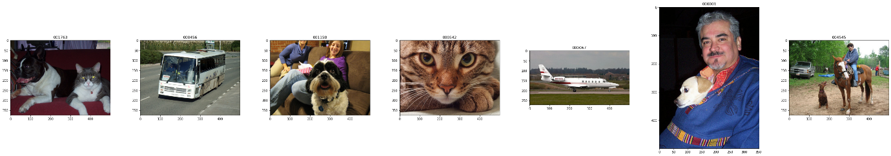

Data augmentation

from tensorflow.keras.preprocessing.image import ImageDataGenerator , load_img

datagen = ImageDataGenerator(rotation_range=40,

zoom_range=0.2,

width_shift_range=0.2,

height_shift_range=0.2,

horizontal_flip=True,

fill_mode = 'nearest')

Manually read each image and create an array to be supplied to datagen via flow method

SIZE = 150

dataset = []

my_images = os.listdir(img_data)

for i, image_name in enumerate(my_images):

if (image_name.split('.')[1] == 'jpg'):

image = io.imread(img_data + image_name)

image = Image.fromarray(image, 'RGB')

image = image.resize((SIZE,SIZE))

dataset.append(np.array(image))

x = np.array(dataset)

#x = x.reshape((1,) + x.shape)

i = 0

#clearing the folder to store augmented data

for f in glob(aug_dir+"/*jpg"):

os.remove(f)

for batch in datagen.flow(x, batch_size=1,

save_to_dir='/content/CNN_data_aug_dataset/augmented',

save_prefix='aug',

save_format='jpg'):

i += 1

if i > 20:

break # otherwise the generator would loop indefinitely

Displaying all augmented images

import glob

import matplotlib.pyplot as plt

import matplotlib.image as mpimg

%matplotlib inline

images = []

for img_path in glob.glob(aug_dir+"/*jpg"):

images.append(mpimg.imread(img_path))

plt.figure(figsize=(30,30))

columns = 5

for i, image in enumerate(images):

plt.subplot(len(images) / columns + 1, columns, i + 1)

plt.imshow(image)

plt.xticks([])

plt.yticks([])